**Title:  Analysis of a Sample and Hold Circuit with Reconstruction Filter**

**Objective:** To understand the operation of a Sample and Hold Circuit and its integration with a reconstruction filter for accurate analog-to-digital conversion.

**Apparatus Required:**

* **Sample and Hold Circuit:**
  + Analog Switch (MOSFET)
  + Holding Capacitor
  + Operational Amplifiers
  + Power Supply
  + Function Generator
  + Oscilloscope
* **Reconstruction Filter:**
  + Low-Pass Filter Components (Resistors, Capacitors)

**Theory :**

A Sample and Hold (S/H) circuit is an essential component in analog-to-digital conversion systems. It operates by sampling the voltage of a continuously varying analog signal and holding this value constant for a specified period of time. Here’s a simplified explanation of how it works:

1. **Sampling Phase**: The circuit receives an analog input signal. A control signal triggers the analog switch (typically a MOSFET or JFET) to close, allowing the input signal to pass through.
2. **Holding Phase**: Once the desired sample is captured, the control signal opens the switch. The sampled voltage is stored on a capacitor, which maintains the voltage level steady as the capacitor cannot discharge through the Op-Amp buffer.
3. **Output**: The input signal is available as the output when MOSFET switch is ON and the held voltage is then available as a stable output when the MOSFET is OFF for a certain duration, known as the holding time.

**Working :**

In the sample and hold circuit, the input signal is provided to the drain terminal of the MOSFET switch. The controlling signal, i.e. the square wave is provided to the gate terminal of the MOSFET switch. The source terminal is then connected to the non-inverting terminal of the Op-Amp with a capacitor in parallel. The Op-Amp is connected in a buffer configuration. The output of the Op-Amp is then connected as the input of a passive Low-Pass filter.

When the positive half of the square wave is applied to the gate of the MOSFET, it turns on and the input signal passes to the Op-Amp output as well as charges the capacitor. When the negative half of the square wave is applied, then the MOSFET turns of and the capacitor holds it’s previous voltage as it is unable to discharge through the Op-Amp buffer. Both of these phases creates the combined output signal of the sample and hold circuit. This signal is then passed through a Low-Pass filter to get the original signal (in this case a pure sinusoid) back 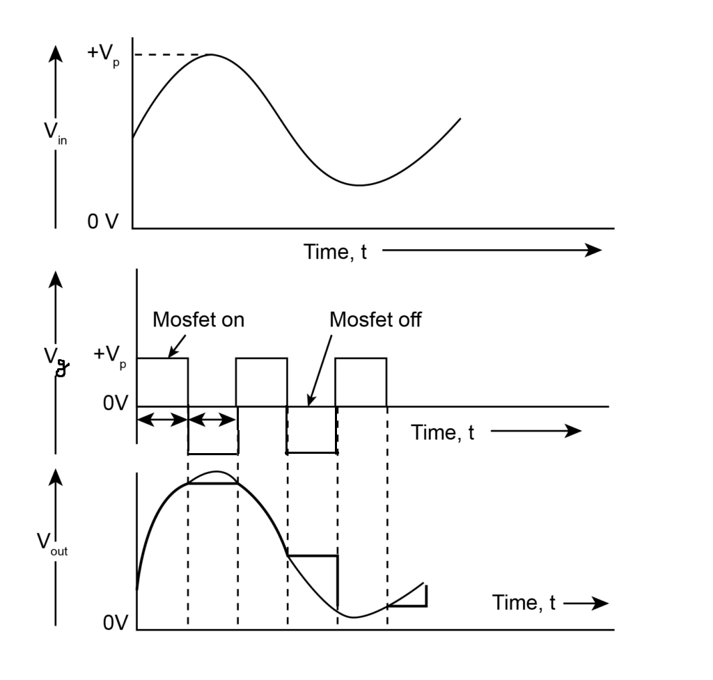

**Procedure:**

1. Construct the basic S/H Circuit using an analog switch and a holding capacitor.
2. Connect the function generator to provide an input analog signal.
3. Observe the sampling and holding phases on the oscilloscope.
4. Implement the reconstruction filter using low-pass filter components.
5. Connect the output of the S/H Circuit to the input of the reconstruction filter.
6. Analyze the output signal using the oscilloscope to verify the removal of high-frequency components.

**Calculations:**

We have to calculate the values of the resistor and capacitor of the Low-Pass Filter using the formula

fc= 1/(2πRC)

Let fc = 1.6 kHz , then value of resistor and capacitor needed is R=1kΩ and C=0.1uF

**Circuit Diagram:**

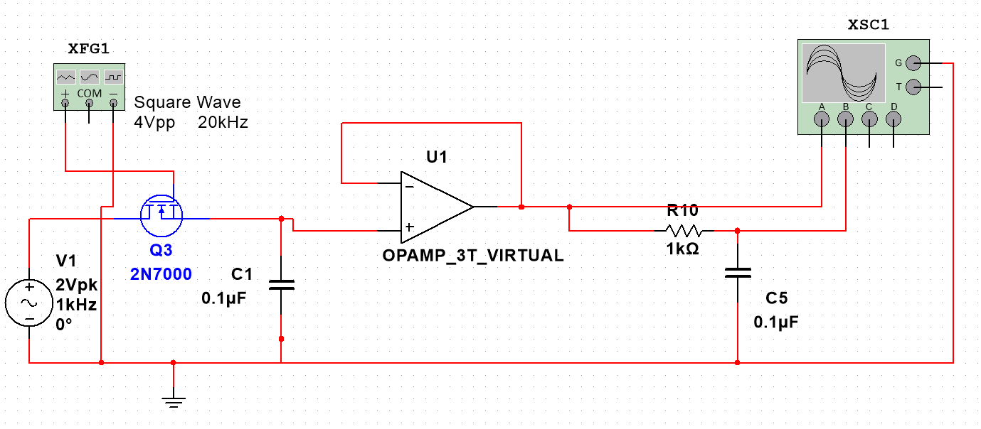

**Waveforms:**

**Results:** The Sample and Hold Circuit successfully sampled the input analog signal and held the value according to the control signal. The reconstruction filter effectively smoothed the digital signal, reconstructing a continuous-time signal that closely resembled the original analog input. By comparing the results at different sampling frequency, we could infer that distortion decreases with increasing sampling frequency.

**Conclusion:** Thus we could understand the working of sample and hold circuit and the reconstruction filter. We could also observe that by increasing the sampling frequency we can reduce distortion of the signal. The integration of the Sample and Hold Circuit with a reconstruction filter is proven to be effective for accurate analog-to-digital conversion. The circuit permits the circuit to catch and manage the instantaneous data or value of the signal.